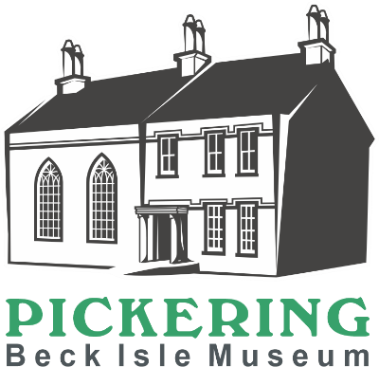
Retail and Admissions Volunteer
We are looking for volunteers who would like to join our enthusiastic and friendly Visitor Services team.

Main Duties
- Creating a warm and friendly welcome for all our visitors
- Answering general enquiries in a professional manner and ensuring that visitors have an enjoyable visit
- Operating the Epos till system and Sum up card machine
- Maintaining a high standard of numeracy and managing card payments
- Selling tickets for entry to museum, taking both cash and card payments
- Selling items within the shop, taking both cash and card payments
- Carrying out visitor surveys
- Undertaking gift aid discussions with all visitors
- Gentle cleaning as needed to provide a high standard of presentation
- Ensuring that the museums health and safety procedures are followed and, in an emergency carrying out the evacuation procedure

How much time will I be expected to give?
The museum is open Monday to Saturday. You can choose to volunteer in a morning (10.15 -1.15pm) or an afternoon (1.15 - 4.30pm). Volunteering hours vary depending on the time you have available. As a guide, we would look for a minimum of 4 sessions per month. We like all our volunteers to choose a regular time slot to support the museum’s opening.

What skills, qualities and experience do I need?
- Commitment to excellent customer service
- Good verbal communication skills
- An interest in heritage and local history
- Ability to handle money and operate an Epos system till
- Good standard of accuracy and experience of cash handling
- Enjoy working as part of a team
- Willingness to undertake relevant training
- Commitment to equality and diversity

What support and training will I receive?
You will receive a welcome training session which includes a tour of the museum, till training and will familiarise you with the Retal and Admissions role. Whilst on the Visitor desk you will be supported by a Visitor Services volunteer. Further training, support and supervision will be provided by the Visitor Services and Collections Manager.

What can I expect from the museum?
- To become part of a motivated and enthusiastic team
- To learn about the museum and local history
- To meet new people within your local community
- To learn new skills
- A 10% discount on selected products within the museum shop
- A rest room with tea and coffee provided
- We are members of the Volunteer Pink Pass. After three months volunteering you will receive a pink pass which entitles you to free and discounted entry to hundreds of museums across the North of England
- Free carparking whilst carrying out volunteering duties (subject to availability)

Other Information
- The role is open to volunteers aged 18+
- This role is not regulated activity and therefore does not require an additional safeguarding (DBS) check
Please complete the application form which can be found on our website www.beckislemuseum.org.uk. Please contact manager@beckislemuseum.org.uk or tel 01751 473653 to arrange an informal chat.

