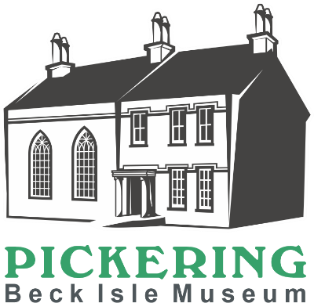
Display and Collections Volunteer
We are looking for volunteers

to join our collections team to assist with the day-to-day care of our collection and redisplays during the closed season (November- March).

Main Duties
- To refresh room or display cases annually, with support from the collections team
- To support the collections team to accurately record objects on display
- To provide a light clean of the rooms and objects on display to present the museum at its best April – October
- Deep clean, vacuum and dust rooms and display areas November- March

How much time will I be expected to give?
It is anticipated that this role will require a minimum commitment of half a day a month and will continue over the winter season, where this may increase to once a week to ensure the rooms and displays are updated and clean ready for reopening.

What skills, qualities and experience do I need?
- An interest in the collection at the museum
- Enjoy working as part of a team but also able to work independently
- Willingness to undergo relevant training
- Ability to accurately and regularly complete paperwork
- Physically able to use the equipment needed to assist with the job, i.e. step ladders, a museum vacuum cleaner, a folding table and chairs (help will be available where needed)
- Physically able to move museum objects with care and control, (help will be available for larger/heavier items)
What support and training will I receive?
You will be managed and supported by the collections team. Relevant training will be provided.
What can I expect from the museum?
- To become part of a motivated and enthusiastic team
- To learn about the museum and local history
- To learn new skills
- A rest room with tea and coffee provided
- A 10% discount in the museum shop on selected products
- Free carparking whilst carrying out volunteering duties (subject to availability)
- We are member of the Volunteer Pink Pass. After three months of volunteering, you will receive a pink pass which entitles you to free and discounted entry to hundreds of museums across the North of England
Other information
- The role is open to volunteers aged 18+
- This role is not regulated activity and therefore does not require an additional safeguarding (DBS) check

Please complete the application form which can be found on our website www.beckislemuseum.org.uk. Please contact manager@beckislemuseum.org.uk or tel 01751 473653 to arrange an informal chat.

