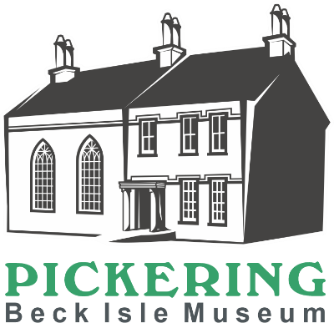
Collections Care Volunteer
We are looking for volunteers to join our Collections team with specific responsibilities to care for the objects on display and in stores.
Main Duties
- Clean objects in appropriate manner to get rid of surface dust and grime
- Assist display and collections volunteers with organising winter cleaning priorities
- Monitor for pest activity – alert collections team to any worrying signs
- Explain to the visitors what you are doing, if you are working in public spaces.

How much time will I be expected to give?
A minimum of three hours twice a month.
What skills, qualities and experience do I need?
- An interest in conservation and cleaning of objects
- A gentle and methodical approach to caring for the collection
- Physically able to use the equipment needed to assist with the job, i.e. step ladders, a museum vacuum cleaner, a folding table and chairs,
- Physically able to move museum objects with care and control, (help will be available for larger/heavier items
- Good verbal communication skills
- An interest in heritage and local history
- Enjoy working as part of a team
- Willingness to undertake relevant training

What support and training will I receive?
You will receive a Collections Care training session which includes a tour of the museum, explanation of the role, how to use equipment and where it is stored. Online training in the form of two videos made by a conservation department on how to surface clean museum objects will be emailed to you before the training at the museum. Further training, support and supervision will be provided by the collections team.
What can I expect from the museum?
- To become part of a motivated and enthusiastic team
- To learn about the museum and local history
- To meet new people within your local community
- To learn new skills
- A 10% discount on selected items within the museum shop
- A rest room with tea and coffee provided
- We are members of the Volunteer Pink Pass. After three months volunteering you will receive a pink pass which entitles you to free and discounted entry to hundreds of museums across the North of England
- Free carparking whilst carrying out volunteering duties (subject to availability)

Other Information
- The role is open to volunteers aged 18+
- This role is not regulated activity and therefore does not require an additional safeguarding (DBS) check

Please complete the application form which can be found on our website www.beckislemuseum.org.uk. Please contact manager@beckislemuseum.org.uk or tel 01751 473653 to arrange an informal chat.

