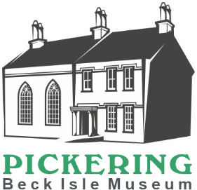
Beck Isle Museum - Volunteer Application form

Thank you for your enquiry about volunteering at Beck Isle Museum.

Date of Application

Title: First Name: Surname:

Address

Postcode Email

Telephone (home) Mobile

There are a number of different volunteer roles. Please indicate which role(s) you may be interested in. Full induction and training will be provided for all roles.

Retail and Admissions |  |  | Display and Collections
Visitor Services |  |  | Collections Care
Events and Family activities |  |  | Collections Cataloguer
School visits and outreach |  |  | Practical helper (e.g. painting, cleaning, gardening etc)
Design / photography / printing |  |  | Craft Demonstrator
Other skills / knowledge (please state) |  | Administration / finance

Please indicate below your preferred day and session(s). AM session is 10.15 - 1.15pm and PM session is 1.15pm - 4.30pm

Monday |  | Tuesday |  | Wednesday |  | Thursday |  | Friday |  | Saturday
am | pm | am | pm | am | pm | am | pm | am | pm | am | pm

Please tell us a little bit about yourself, including why you are interested in volunteering at Beck Isle Museum.

Please tell us about any previous experience that you think would be useful in this volunteer role – this could be experience as a volunteer or paid employment.

How did you hear about volunteering at Beck Isle Museum?

Please supply the names of two referees. Referees should have known you for a period of 3 years or more and should not be related to you.

Referee 1 – Name:

Address:

Email:

Tel No:

Referee 2 – Name:

Address:

Email
Tel. No.

Do you have any criminal convictions that are not ‘spent’? Yes No
If ‘Yes’, please give details on an additional sheet of paper.

If you are accepted as a volunteer you will be asked to provide proof of identity (passport, driving licence or bus pass) as well as proof of residence (council tax or utility bill).
Data Protection Act 1998 and 2018. Beck Isle Museum will only use the information provided by you to assess your suitability to volunteer with us and to support you in your volunteering role. This information will be removed from our database when you notify us that you no longer wish to volunteer. We reserve the right to gather information from other sources too, for example, by using your references.
Please return this form to:
Beck Isle Museum, Beck Isle, Pickering, YO18 8DU
Tel 017514735653 or email completed form to manager@beckislemuseum.org.uk

